**PROJECT 2.**

**SALES PERFORMANCE DASHBOARD**

**OVERVIEW:**

The primary goal of this project is to develop an interactive and insightful Power BI dashboard that provides a comprehensive view of sales performance across multiple dimensions—products, employees, and regions. By analysing key sales metrics, the dashboard will help stakeholders understand sales trends, employee performance, and regional market dynamics, enabling data-driven decision-making.

**DATA DESCRIPTION:**

The project leverages three key datasets:

1. Sales Transactions Data:
   * Purpose: Captures individual sales transactions across various stores.
   * Key Columns:
     + Transaction ID: Unique identifier for each transaction.
     + Store ID: Identifier for the store where the transaction occurred.
     + Date: Date of the transaction.
     + Product ID & Name: Identifiers and names of the products sold.
     + Product Category: The category of the product (e.g., Electronics).
     + Units Sold: The quantity of products sold in each transaction.
     + Sales Amount: The revenue generated from each transaction.
     + Region: The geographical region where the store is located.
     + Employee ID: Identifier for the employee handling the sale.
     + Transaction Type: The payment method used (e.g., Cash).
2. Employee Performance Data:
   * Purpose: Tracks the performance of individual employees over time.
   * Key Columns:
     + Employee ID: Unique identifier for each employee.
     + Date: The date of the performance record.
     + Total Sales Amount: Total revenue generated by the employee.
     + Total Units Sold: Number of units sold by the employee.
     + Region: The region where the employee operates.
3. Regional Market Data:
   * Purpose: Provides insights into the overall market trends and performance across different regions.
   * Key Columns:
     + Region: The geographical region of the sales.
     + Date: The date of the market data record.
     + Total Sales Amount: Total revenue generated in the region.
     + Total Units Sold: Total quantity of products sold in the region.
     + Market Trend Index: An index representing the overall market trend in the region.

**KEY ACHIEVEMENTS:**

1. **Enhanced Sales Insights:**
   * The dashboard offers a clear understanding of sales performance across various product categories, helping to identify best-selling products and those that require attention.
   * Sales trends over time reveal patterns and seasonality, aiding in better forecasting and inventory management.
2. **Improved Employee Performance Analysis:**
   * The detailed analysis of employee performance enables the identification of top performers and highlights areas for improvement.
   * The insights into employee efficiency and contribution across regions allow for targeted training and incentive programs.
3. **Comprehensive Regional Market Analysis:**
   * The regional market analysis offers a nuanced view of how different regions contribute to overall sales, revealing both strengths and opportunities for growth.
   * The Market Trend Index helps in understanding the external factors influencing sales, allowing the company to align its strategies with market conditions.

**FUTURE RECOMMENDATIONS:**

1. **Continuous Data Updates:**
   * Regularly update the dashboard with the latest sales data to ensure it remains a relevant and timely tool for decision-making.
2. **Expand Analytical Capabilities:**
   * Incorporate predictive analytics to forecast future sales trends based on historical data.
   * Add customer demographic data to further refine insights and strategies.
3. **Employee Engagement:**
   * Use the insights gained from the dashboard to develop targeted employee training and development programs.
   * Implement recognition programs based on the performance metrics highlighted in the dashboard.

**KEY METRICS AND MEASURES:**

* Total Sales Amount: Aggregated revenue across various dimensions (e.g., product, region, employee).
* Total Units Sold: Sum of all units sold across transactions.
* Sales per Unit: A measure of efficiency, calculated as Total Sales Amount / Total Units Sold.
* Employee Contribution: The proportion of total sales attributed to each employee.
* Market Share: The share of total sales in a region compared to the overall market sales.

**DASHBOARD PAGES:**

1. **Sales Overview:**
   * **Focus:** High-level summary of sales performance.
   * **Visuals:** Sales by product category, sales trends over time, sales distribution by region, and store performance.
   * **Insights:** Helps identify top-performing products, regions, and stores, and tracks overall sales trends.

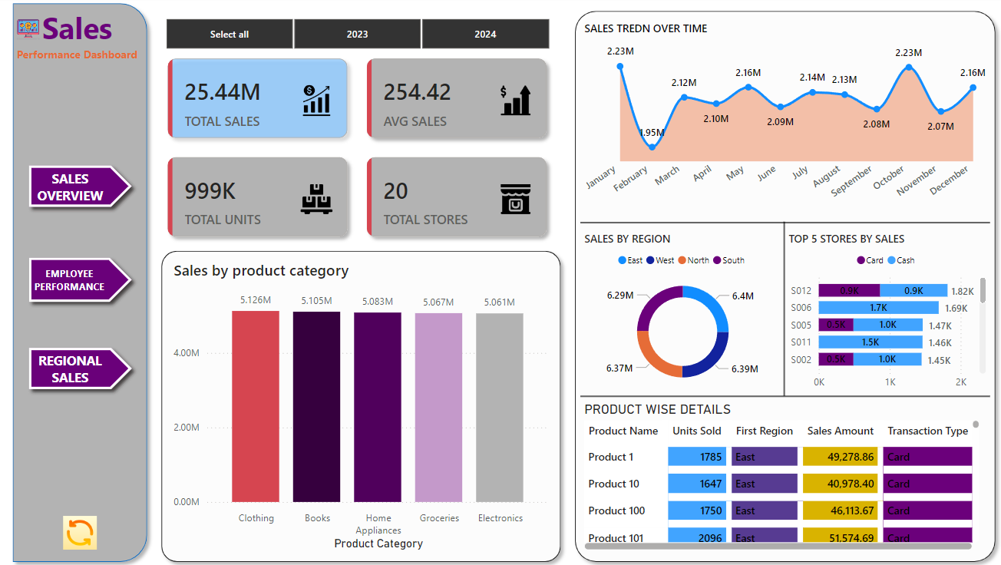

1. **Employee Performance:**
   * **Focus:** Detailed analysis of individual employee contributions to sales.
   * **Visuals:** Top employees by sales, employee performance trends, sales efficiency, and regional employee contributions.
   * **Insights:** Identifies top-performing employees, assesses their efficiency, and evaluates regional contributions.

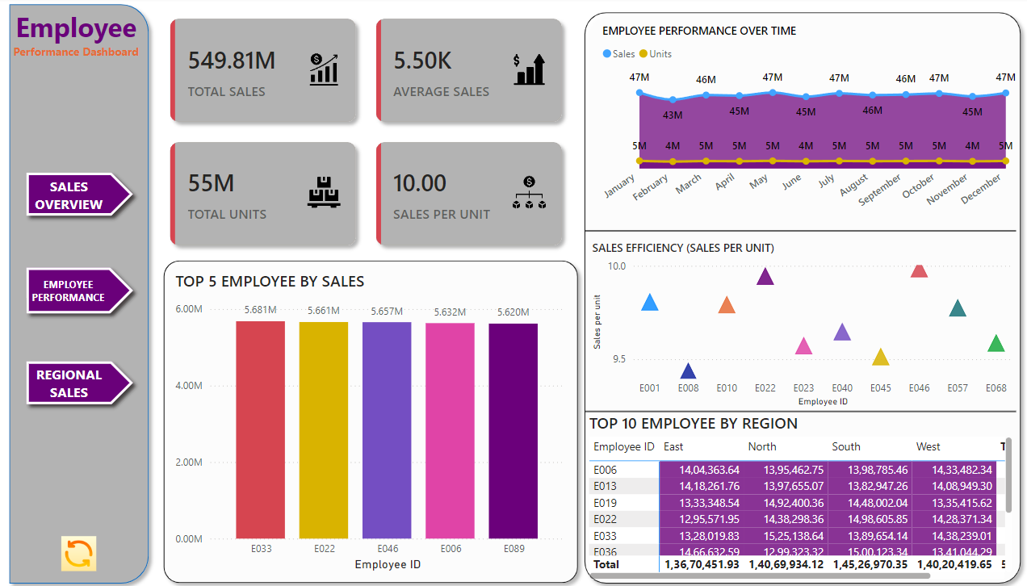

1. **Regional Market Analysis:**
   * **Focus:** Analysis of sales performance and market trends across different regions.
   * **Visuals:** Market trend index vs. sales, regional sales trends, market share heat maps, and sales growth analysis.
   * **Insights:** Provides a deeper understanding of how different regions are performing, tracks market trends, and identifies growth opportunities.

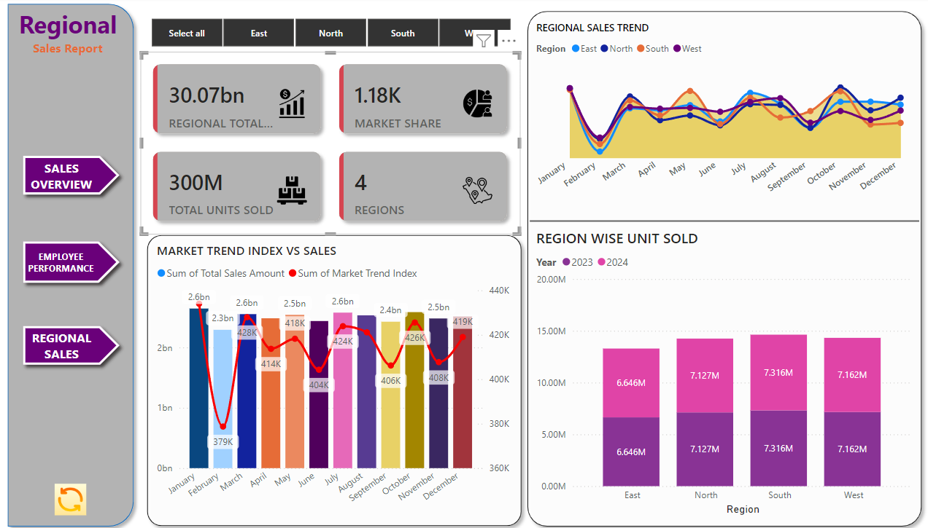

**SUGGESTED GRAPHS AND KPI’S:**

* **Bar/Column Charts:** To compare categorical data (e.g., sales by product category, performance by employee).
* **Line Charts:** To track changes over time (e.g., sales trends, market trends).
* **Pie/Donut Charts:** To show proportions (e.g., sales by region, payment methods).
* **Scatter Plots:** To explore relationships between variables (e.g., sales vs. units sold).
* **Heat Maps:** To visualize data density (e.g., market share across regions and time).
* **Stacked Charts:** To show parts of a whole (e.g., transaction types by store).

**EXPECTED OUTCOMES:**

* **Identify Sales Trends:** Gain insights into how sales vary over time, across products, regions, and employees.
* **Enhance Employee Performance:** Identify top-performing employees and understand the factors driving their success.
* **Regional Market Insights:** Understand regional differences in sales performance and market trends to optimize strategies.
* **Data-Driven Decision Making:** Enable stakeholders to make informed decisions based on comprehensive sales analysis.

**TARGET AUDIENCE:**

* **Sales Managers:** To monitor sales performance and identify areas for improvement.
* **Regional Managers:** To understand how their regions are performing and develop strategies accordingly.
* **Executive Team:** To gain a high-level overview of the company's sales performance and drive strategic initiatives.

**CONCLUSION:**

The Sales Performance Analysis Dashboard successfully fulfills its objective of providing a detailed, data-driven view of the company’s sales activities. By empowering stakeholders with real-time insights into product performance, employee efficiency, and regional trends, the dashboard will play a crucial role in driving the company’s growth and success in the competitive market landscape.